COURSE CODE : ITA1430
COURSE NAME : ETHICAL HACKING

EXPERIMENT – 4

4.Directory and File Display Commands
Aim
To execute ls, cat, and mkdir commands.
Theory
ls Command
Lists files and directories.
ls
cat Command
Displays file contents.
cat file.txt
mkdir Command
Creates a new directory.
mkdir EthicalHacking
Procedure
- Create a directory using mkdir.
- List files using ls.
- Create a text file.
- Display file contents using cat.

Output:
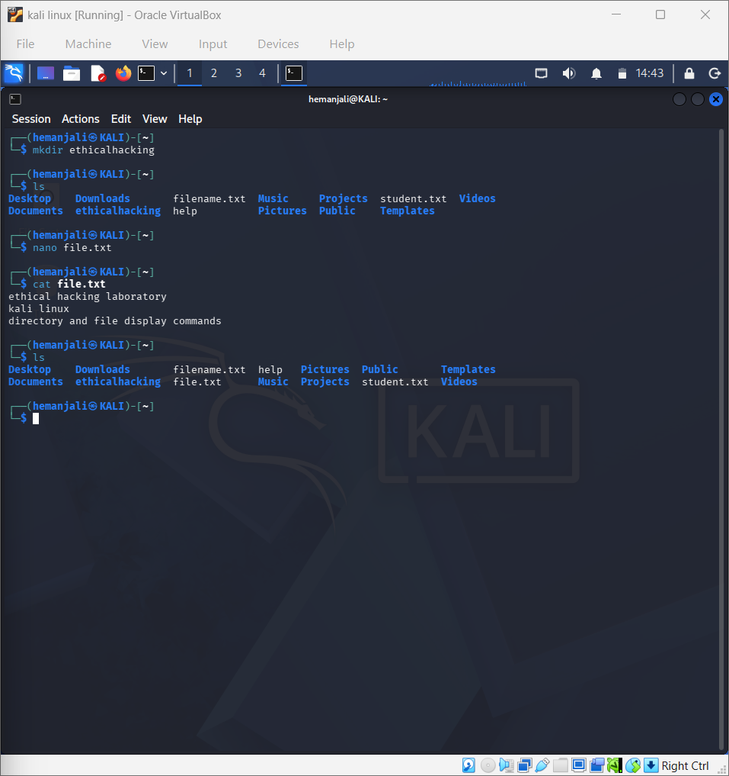
Result
Successfully executed ls, cat, and mkdir commands.

